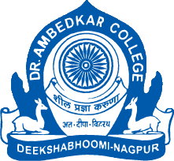
PARAM POOJYA DR. BABASAHEB AMBEDKAR SMARAK SAMITI’S
DEPARTMENT OF LAW
NAAC REACCREDITED WITH ‘A’ GRADE
RECOGNIZED AS COLLEGE WITH POTENTIAL FOR EXCELLENCE BY UGC
DEEKSHABHOOMI, NAGPUR – 440010 (M.S.)

NAME OF THE PROGRAM | WORKSHOP ON CONTRACT DRAFTING AND APPEARANCES BEFORE THE TRIBUNAL
ORGANISING DEPARTMENT/ NAME THE CELL | NOUVEAU CORPORATE CLUB OF DEPARTMENT OF LAW  AND THE INSTITUTE OF COMPANY SECRETARIES OF INDIA, NAGPUR CHAPTER
PROGRAM CO-ORDINATORS FROM THE DEPARTMENT OF LAW AND  FROM THE INSTITUTE OF COMPANY SECRETARIES OF INDIA, NAGPUR CHAPTER | - DR. PRATIMA LOKHANDE  - MS. ANUSHA PATRE  - CS KHUSHAL BAJAJ  - MR. SUDHAKAR A.
DATE | 27TH APRIL 2023
RESOURCE PERSON | - CS MONICA BHATTAD  - CS JAY SODANI
NUMBER OF STUDENTS | 34

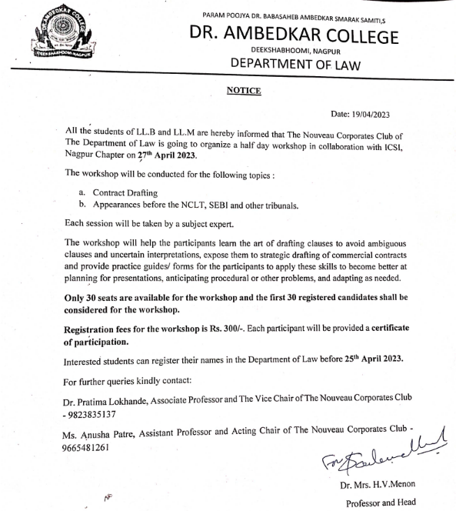
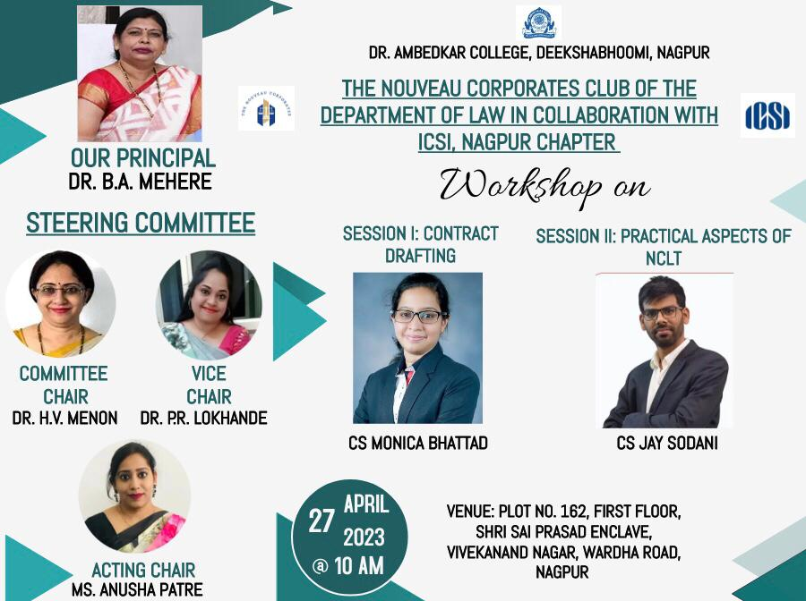
REPORT
The Nouveau Corporates Club of The Departrment of Law, Dr. Ambedkar College, deekshabhoomi, Nagpur organized a workshop in collaboration with ICSI Nagpur Chapter on 27th April 2023. This was the first collaborative activity undertaken by the Club.
The aim and purpose of the workshop was to help the students get acquainted with the most essential skill that a legal and a corporate professional must have – Contract Drafting.
Apart from contract drafting the second session taken in the workshop was the structuring of pleadings before the NCLT and NCLAT. Also it aimed at faculty exchange between the Department of Law, Dr. Ambedkar College, deekshabhoomi, Nagpur and ICSI Nagpur Chapter of WIRC of ICSI.

Ms. Adina Collins and Mr. Benhur Masih, students of LL.M II Semester conducted the proceedings and proposed a Vote of thanks respectively.

The programme of workshop started with the welcoming the resource persons – CS Monica Bhattad and CS Jay Sodani, Head of the Department of Law and Committee Chair of The Nouveau Corporates Club Dr. Mrs. H.V Menon, Associate Professor and Vice Chair of The Nouveau Corporates Club Dr. Ms. Pratima Lokhande, Assistant Professor and Acting Chair of The Nouveau Corporates Club Ms. Anusha Patre, Chairman of the ICSI Nagpur Chapter CS Khushal Bajaj and Secretary of the ICSI Nagpur Chapter CS Mohit Batra. Dr. Mrs H.V Menon, highlighting the importance of the workshop by citing that drafting any agreement in a wrong way makes the strongest party lose a winning case, delivered the welcome address.

CS Khushal Bajaj in his introductory remarks focused upon the significance of Law and CS and how these professions can help the participants achieve new heights in their professional career.

The first technical session on contract drafting by taken by CS Monica Bhattad. The guest speaker held the participants spell bound by her elaborative, elegant and informative lecture immediately after an ice breaker game. She commenced her lecture with the definition of contract and its basic concepts. She elaborated on how artificial intelligence is taking over the drafting done by the professionals and its drawbacks. Her session was interactive with some activity based learning.

The second technical session on legal aspects and pleadings before the NCLT was taken by CS Jay Sodani, a visiting faculty at Department of Law, Dr. Ambedkar College, Deekshabhoomi, Nagpur. By showing a live proceeding of the NCLT, Mumbai and citing the various provisions under the Companies Act, Competition Act and Insolvency and Bankruptcy Code he conveyed how NCLT and NCLAT works and The difference between tribunals and courts. He concluded the session with a discussion with the students regarding the recent decision of NCLT delivered on Google case and its after effects on the global market.

The outcome of the lecture was that, the participants learnt the art of drafting clauses to avoid ambiguous clauses and uncertain interpretations and how to plan for presentations, anticipate procedural or other problems and adapt them as needed.

The workshop successfully culminated with a vote of thanks and lunch for the participants.

Some glimpses of the workshop:

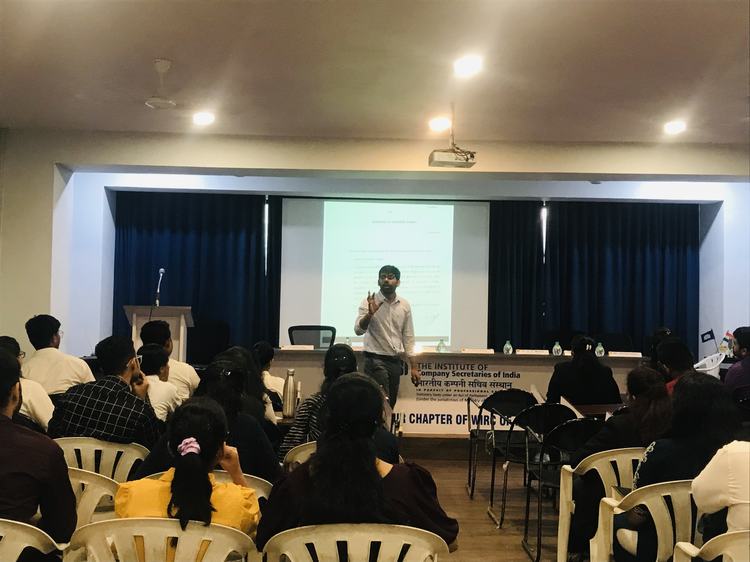

CS Jay Sodani addressing the students

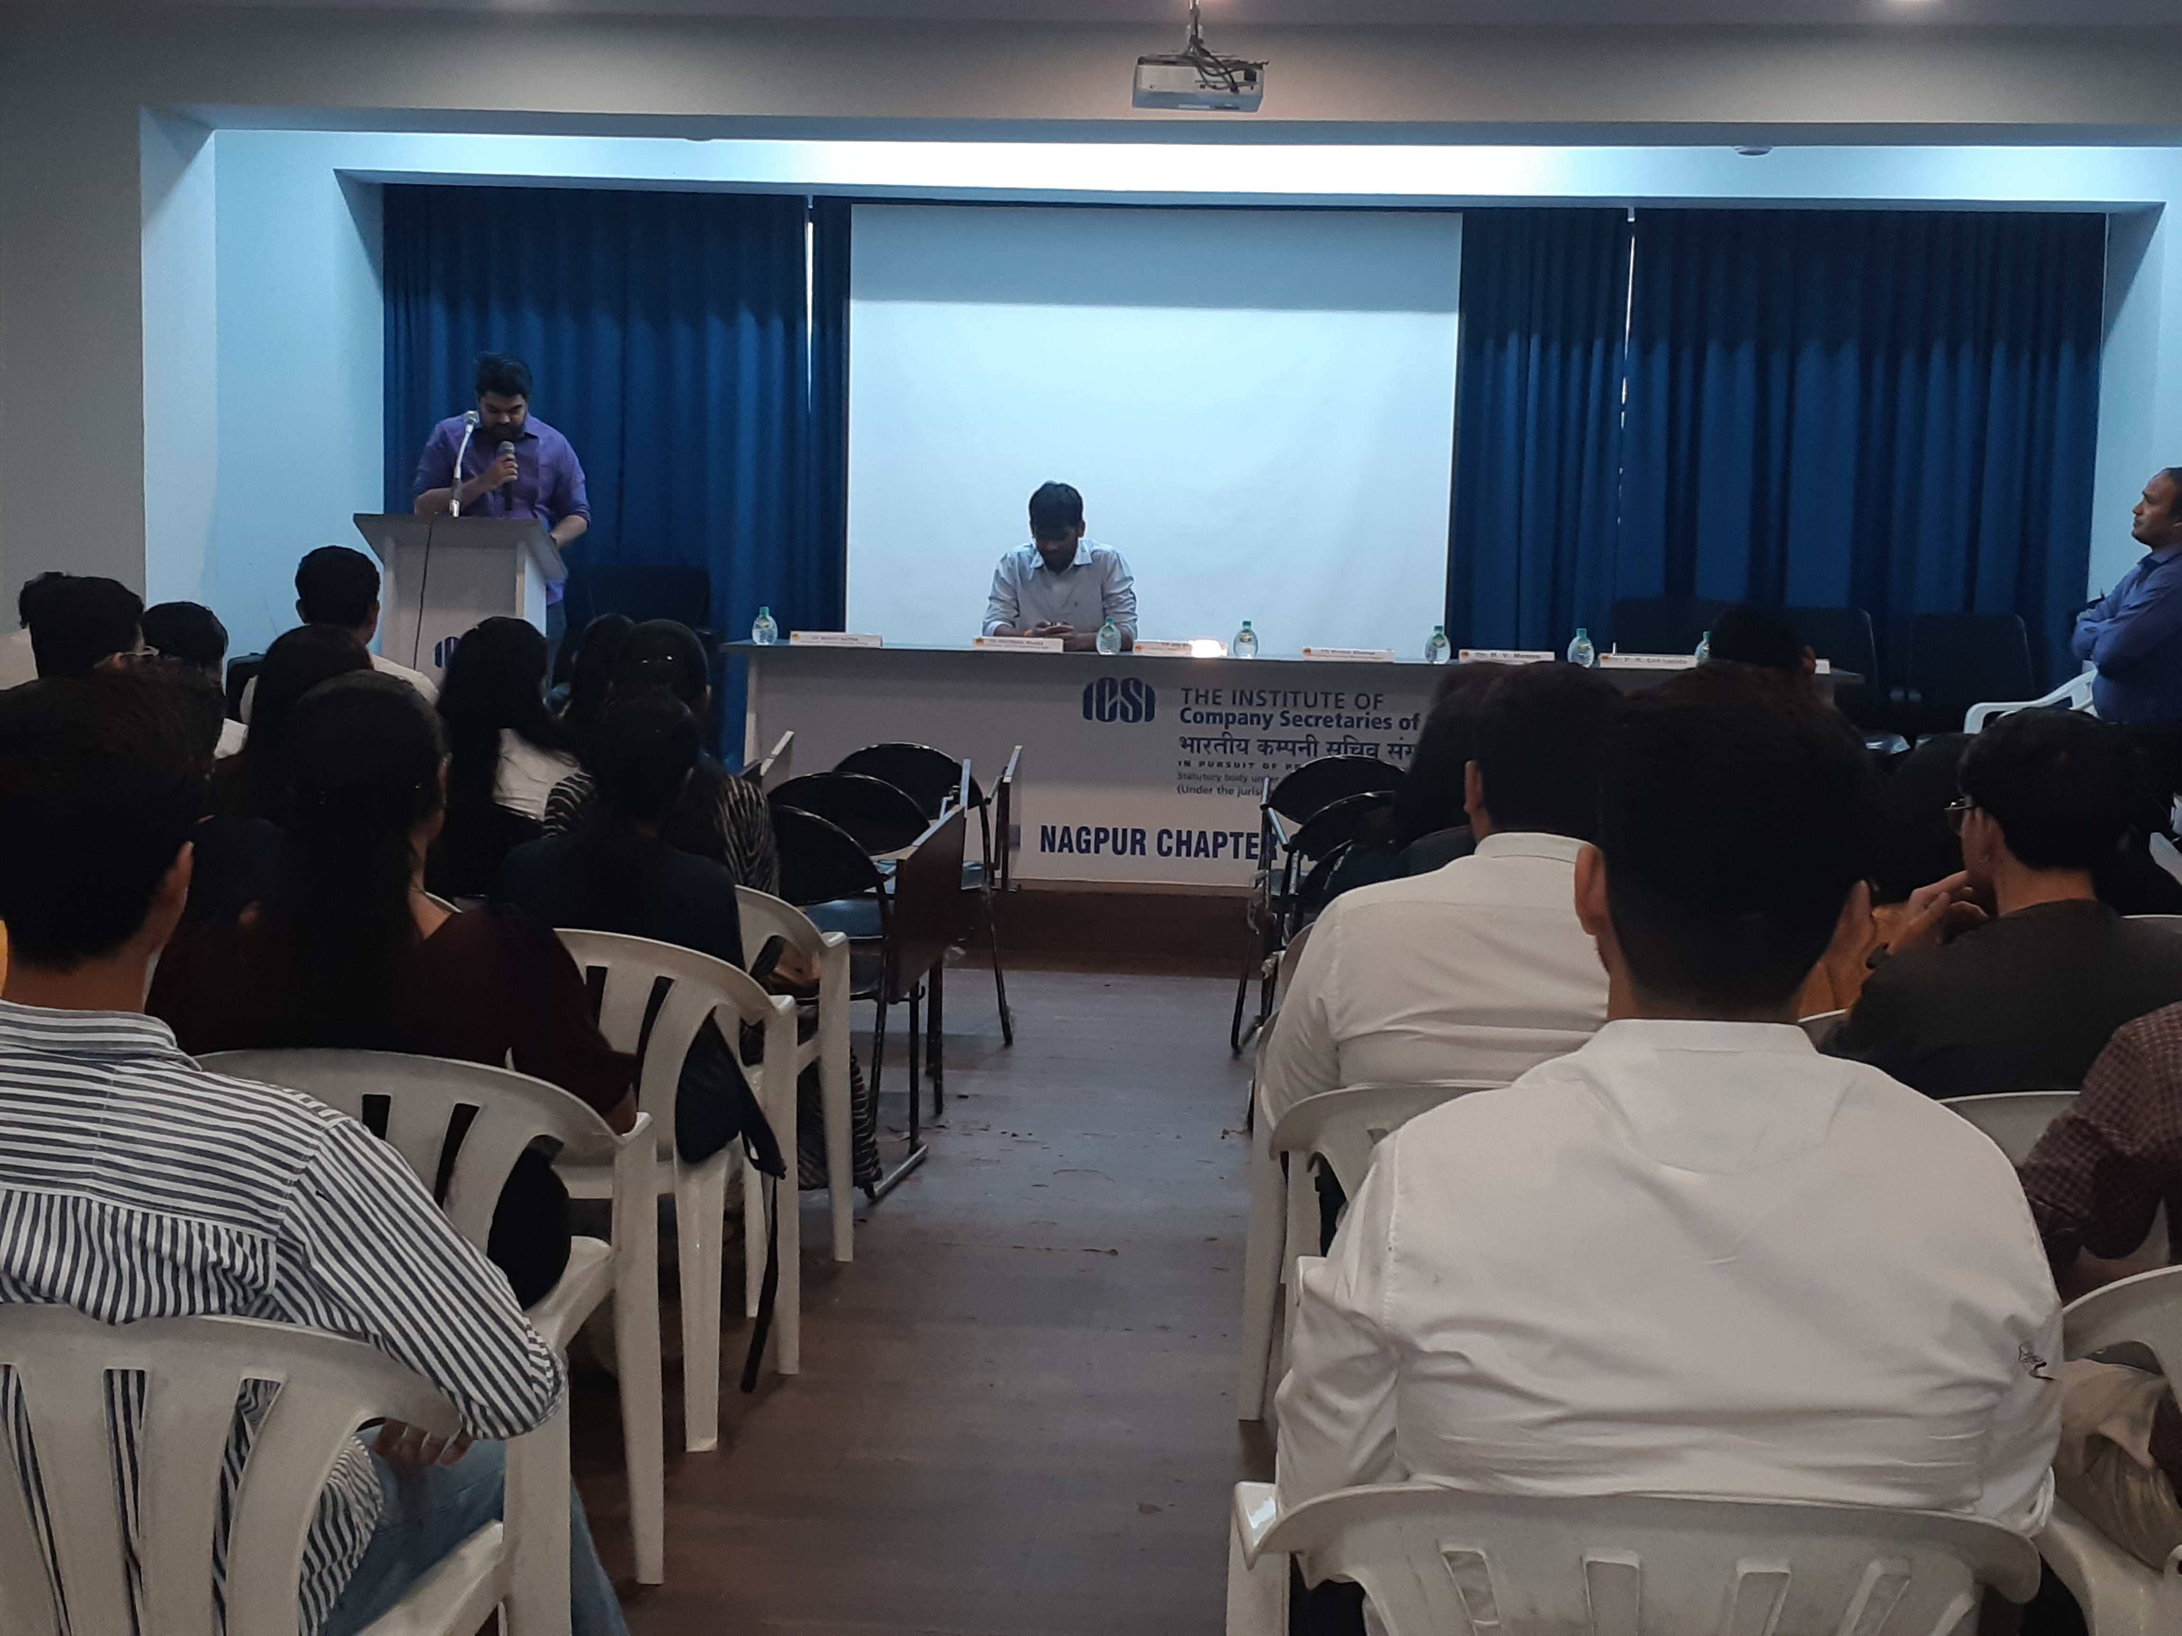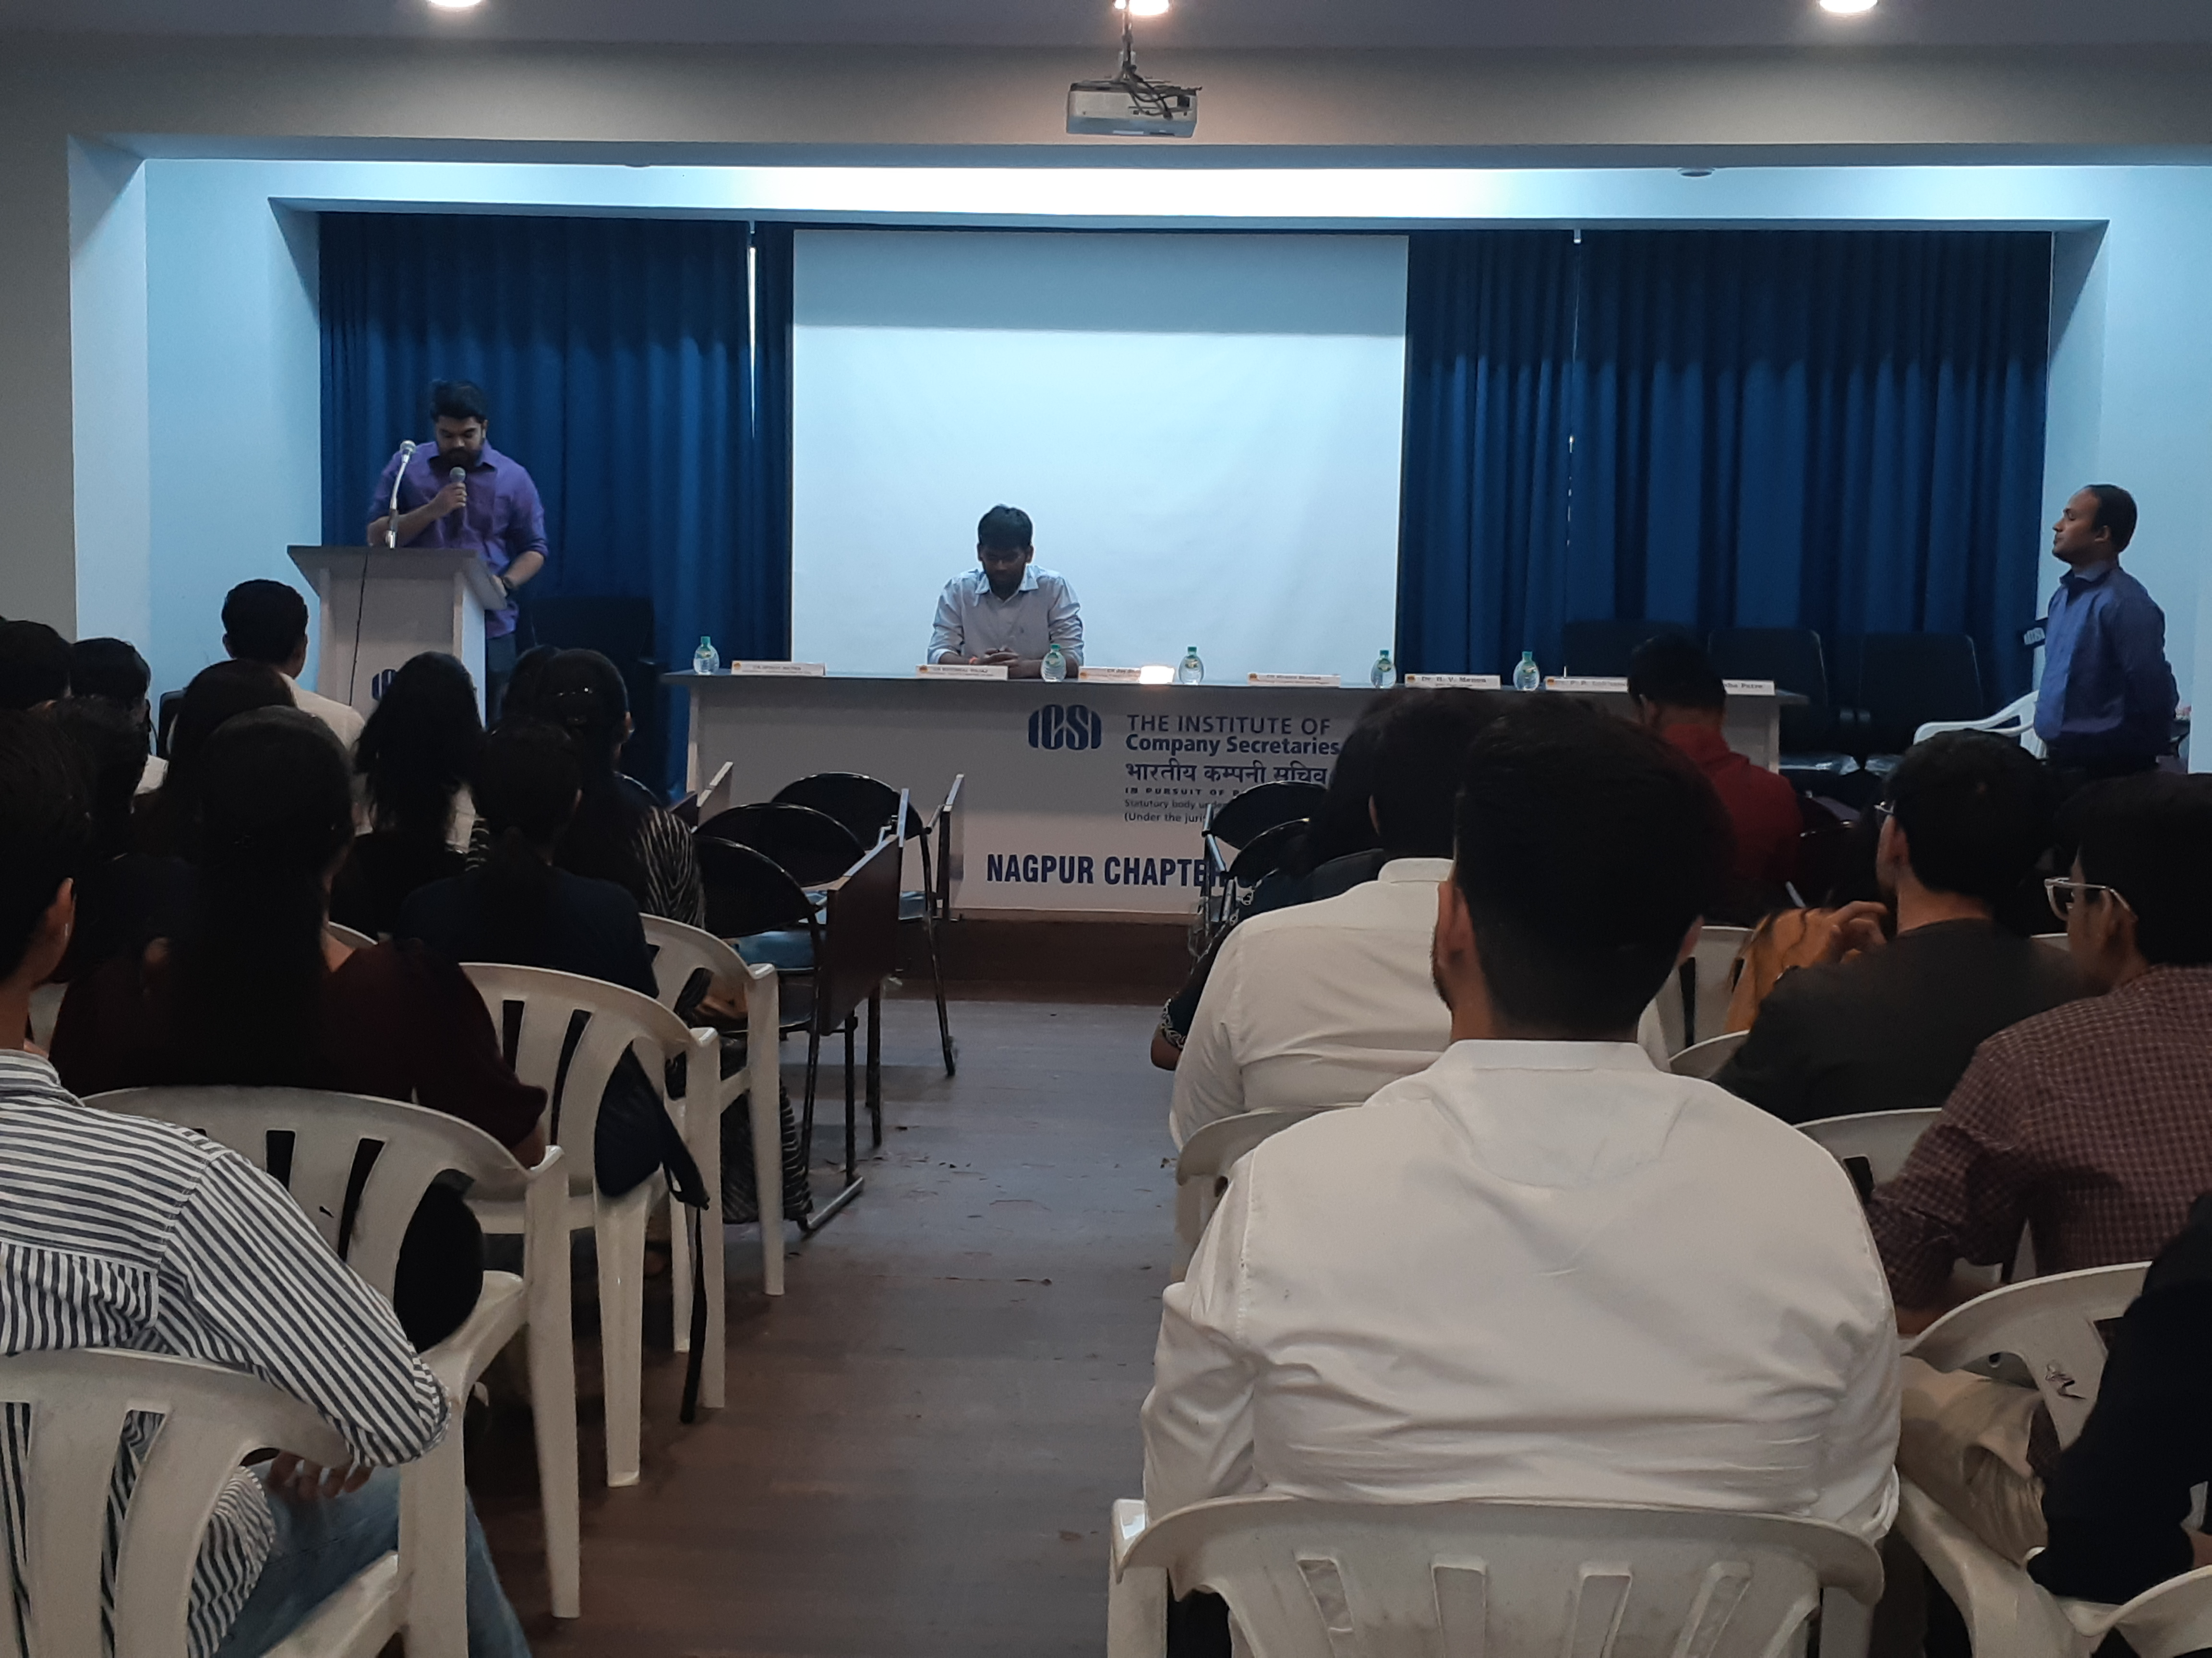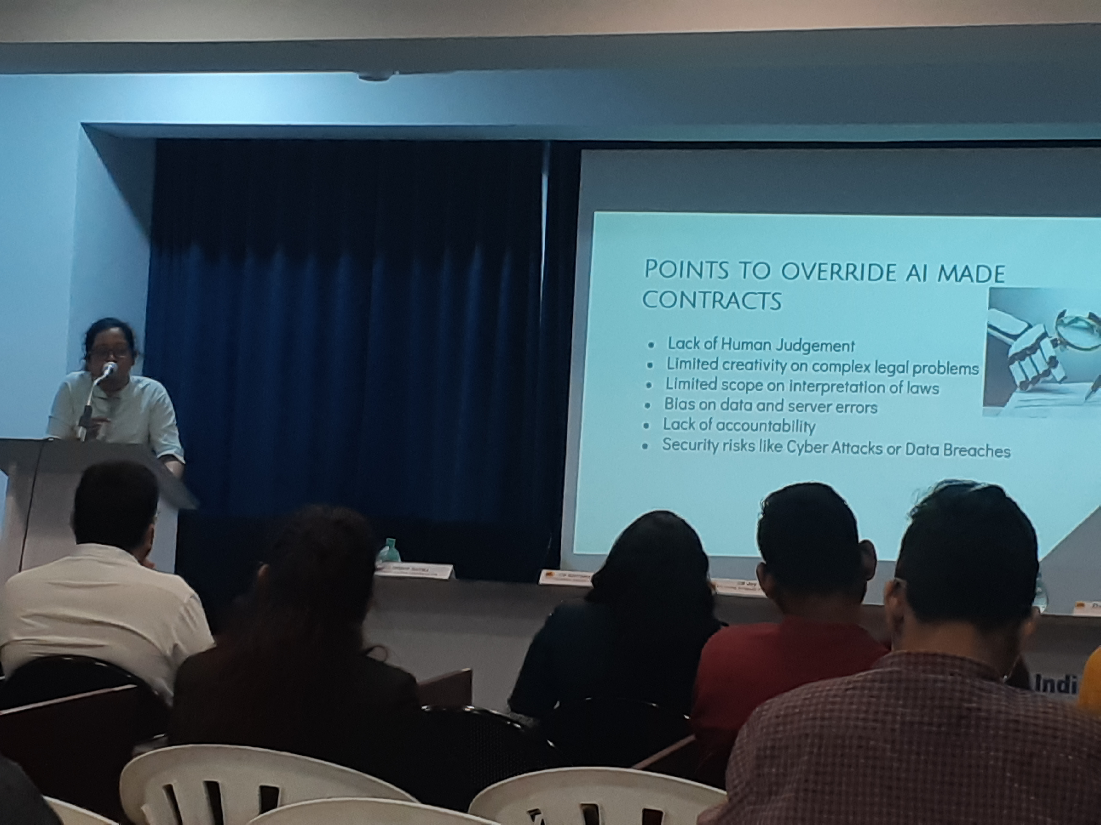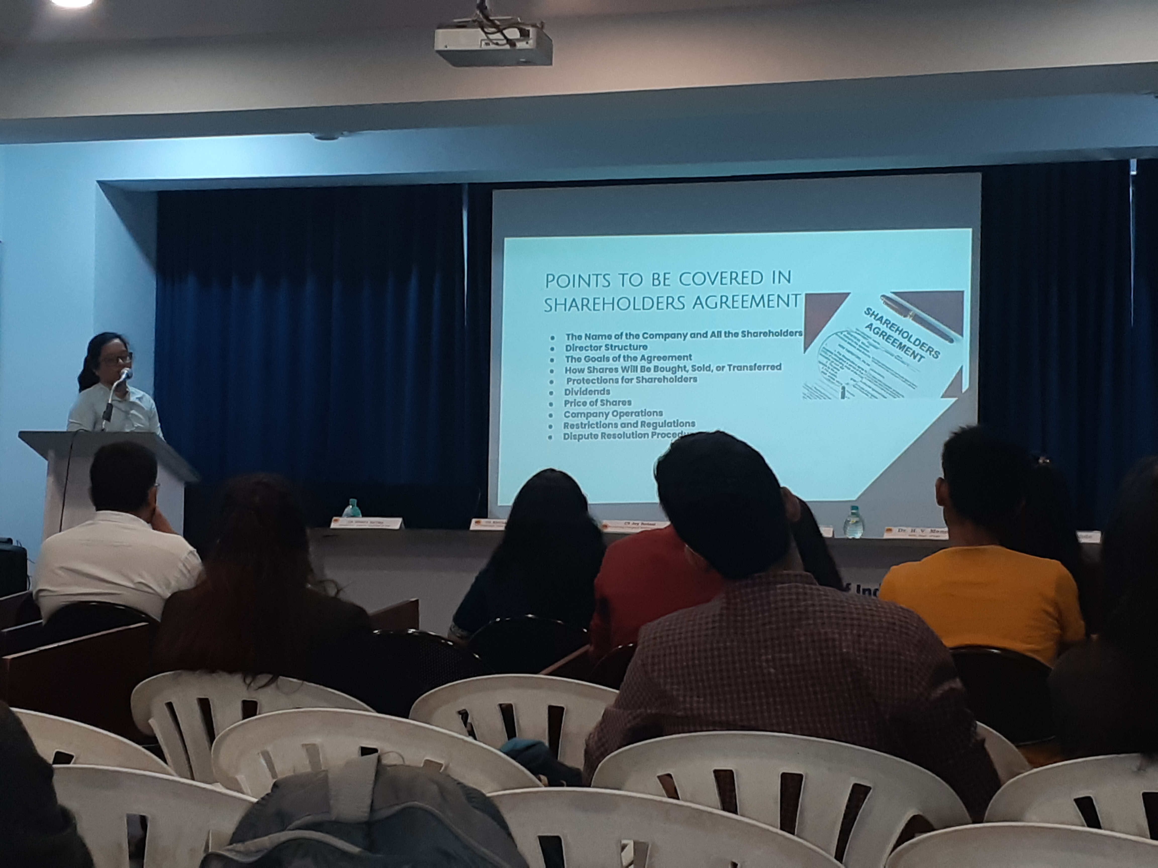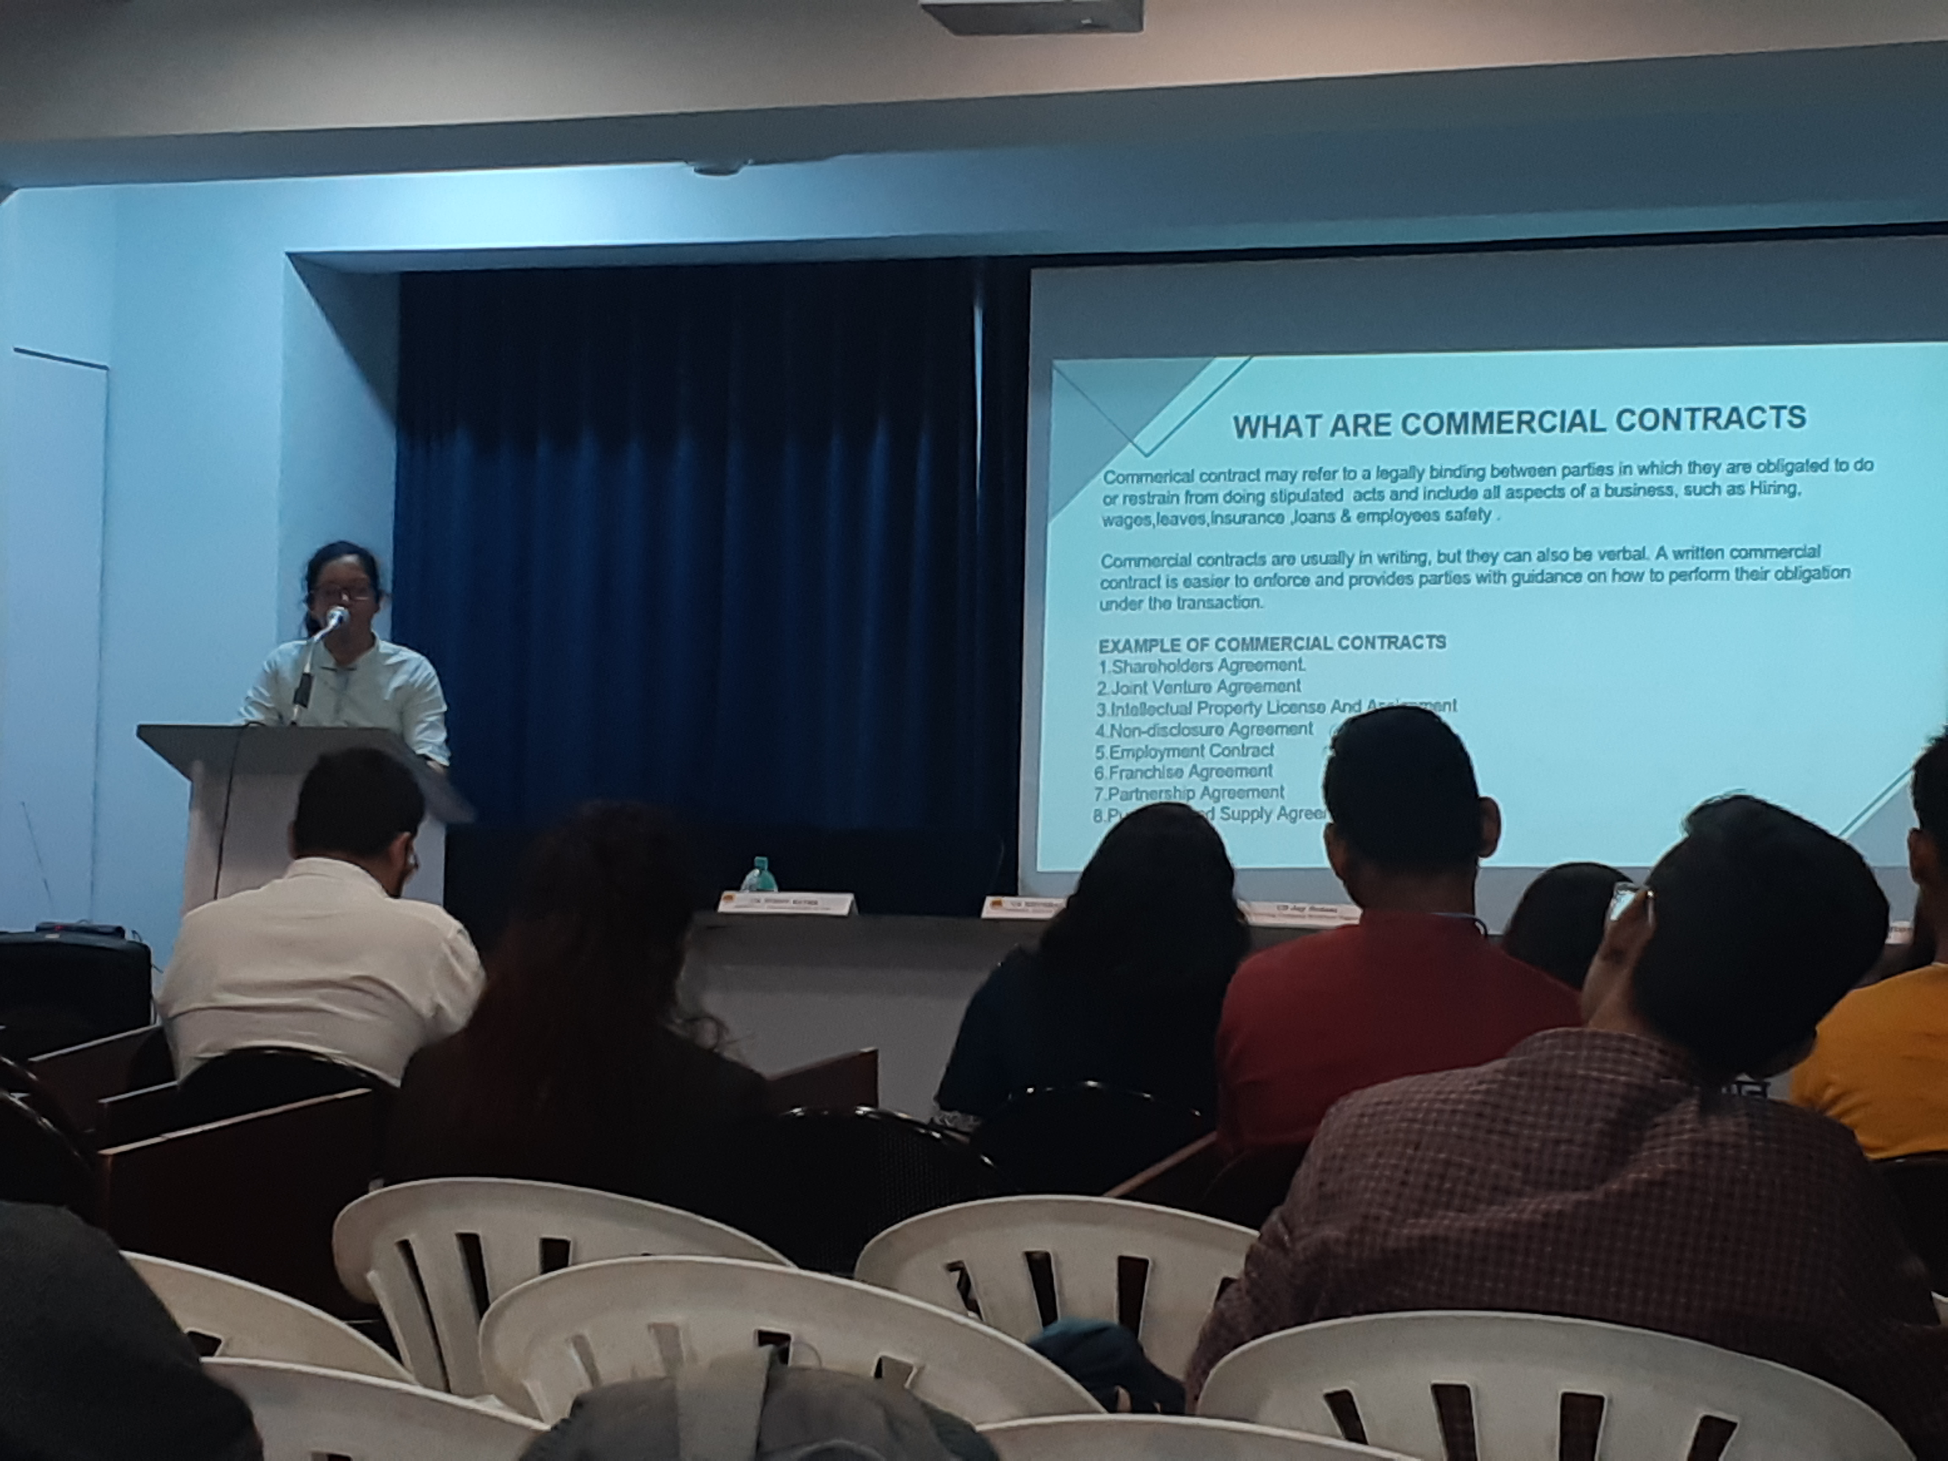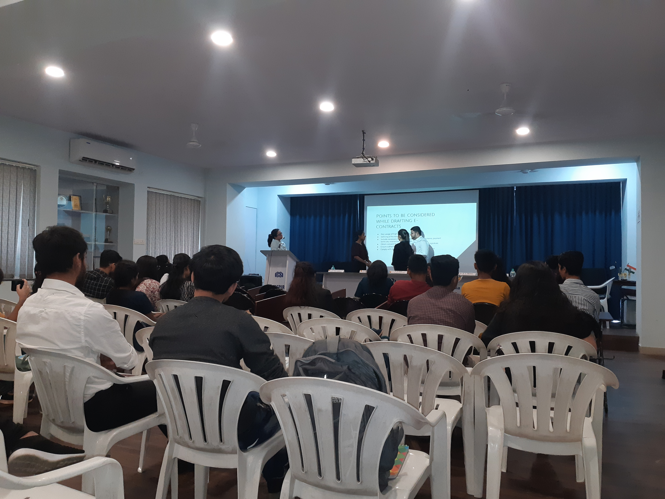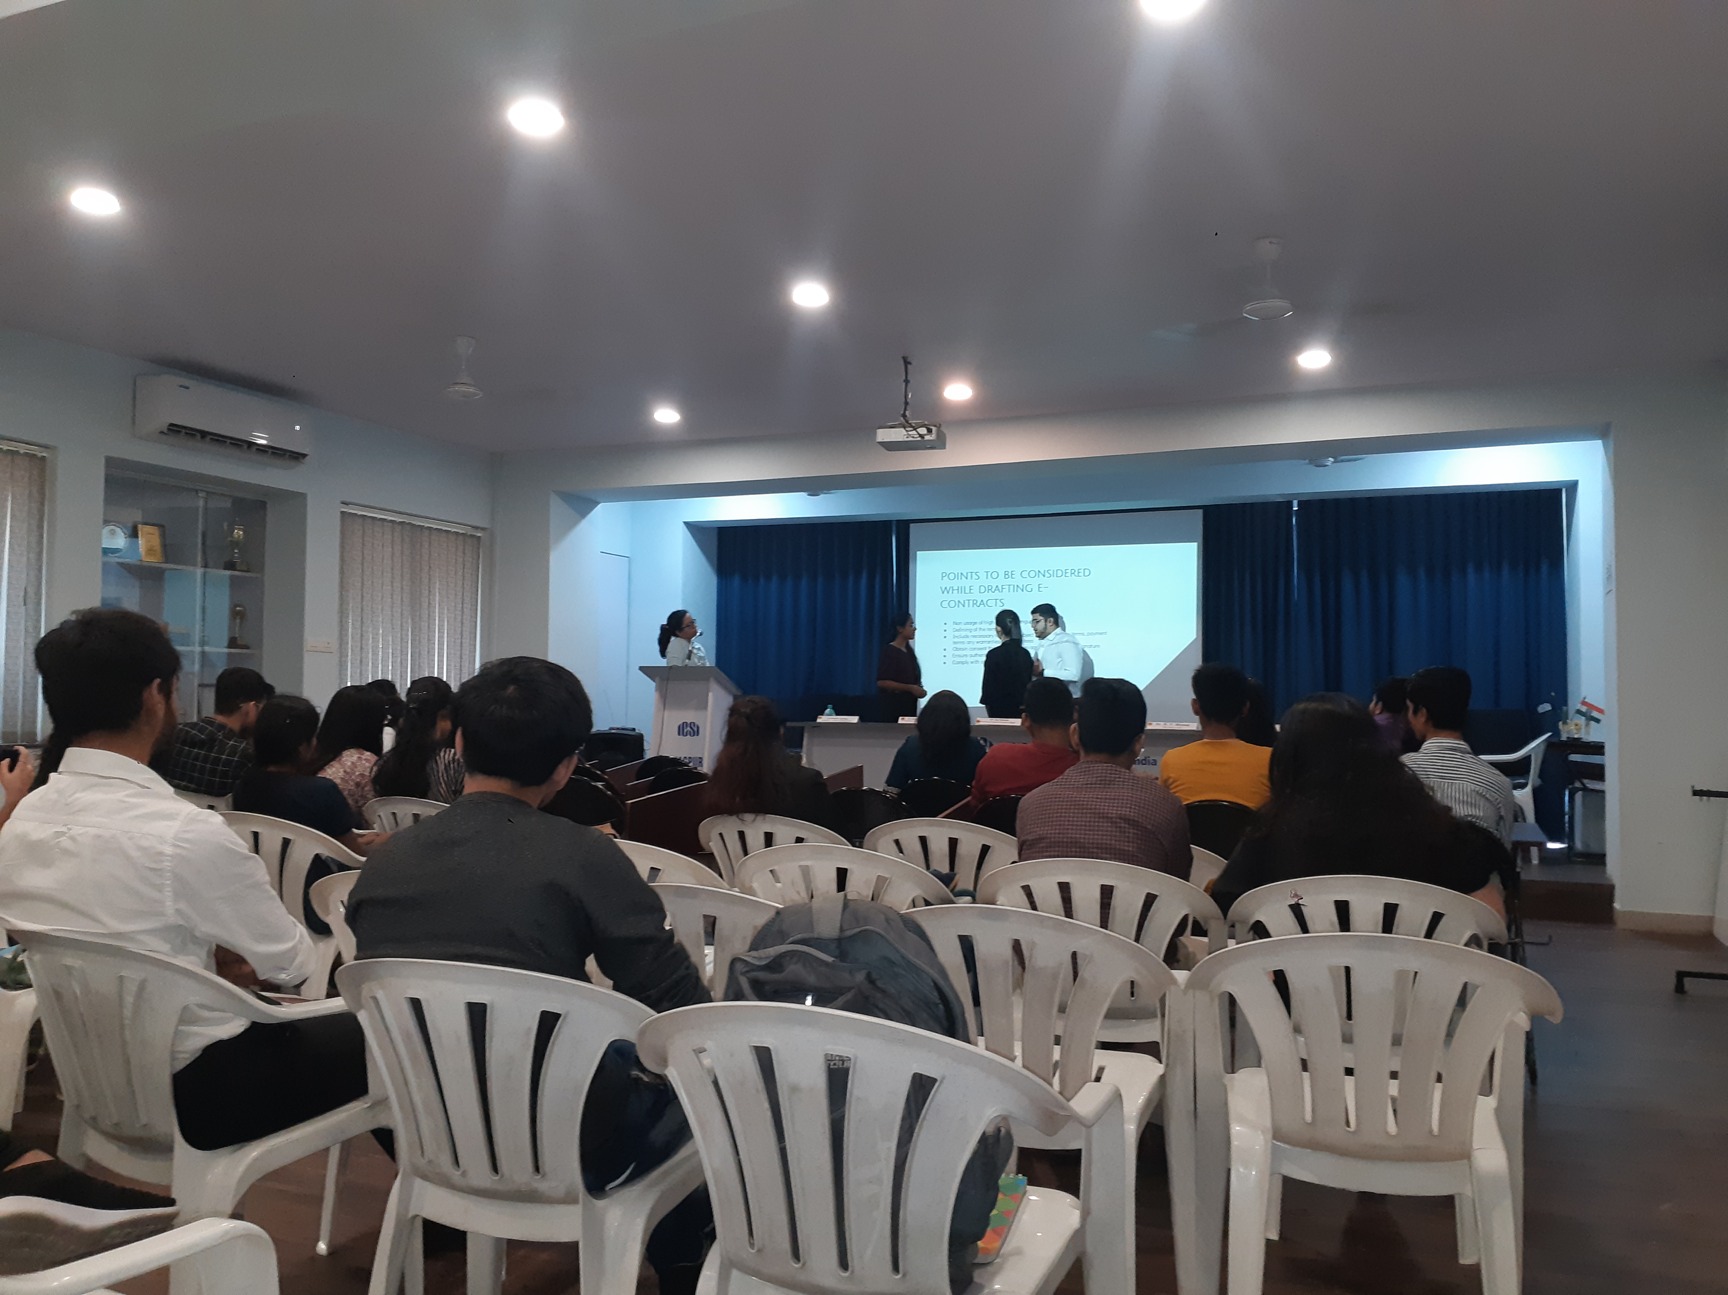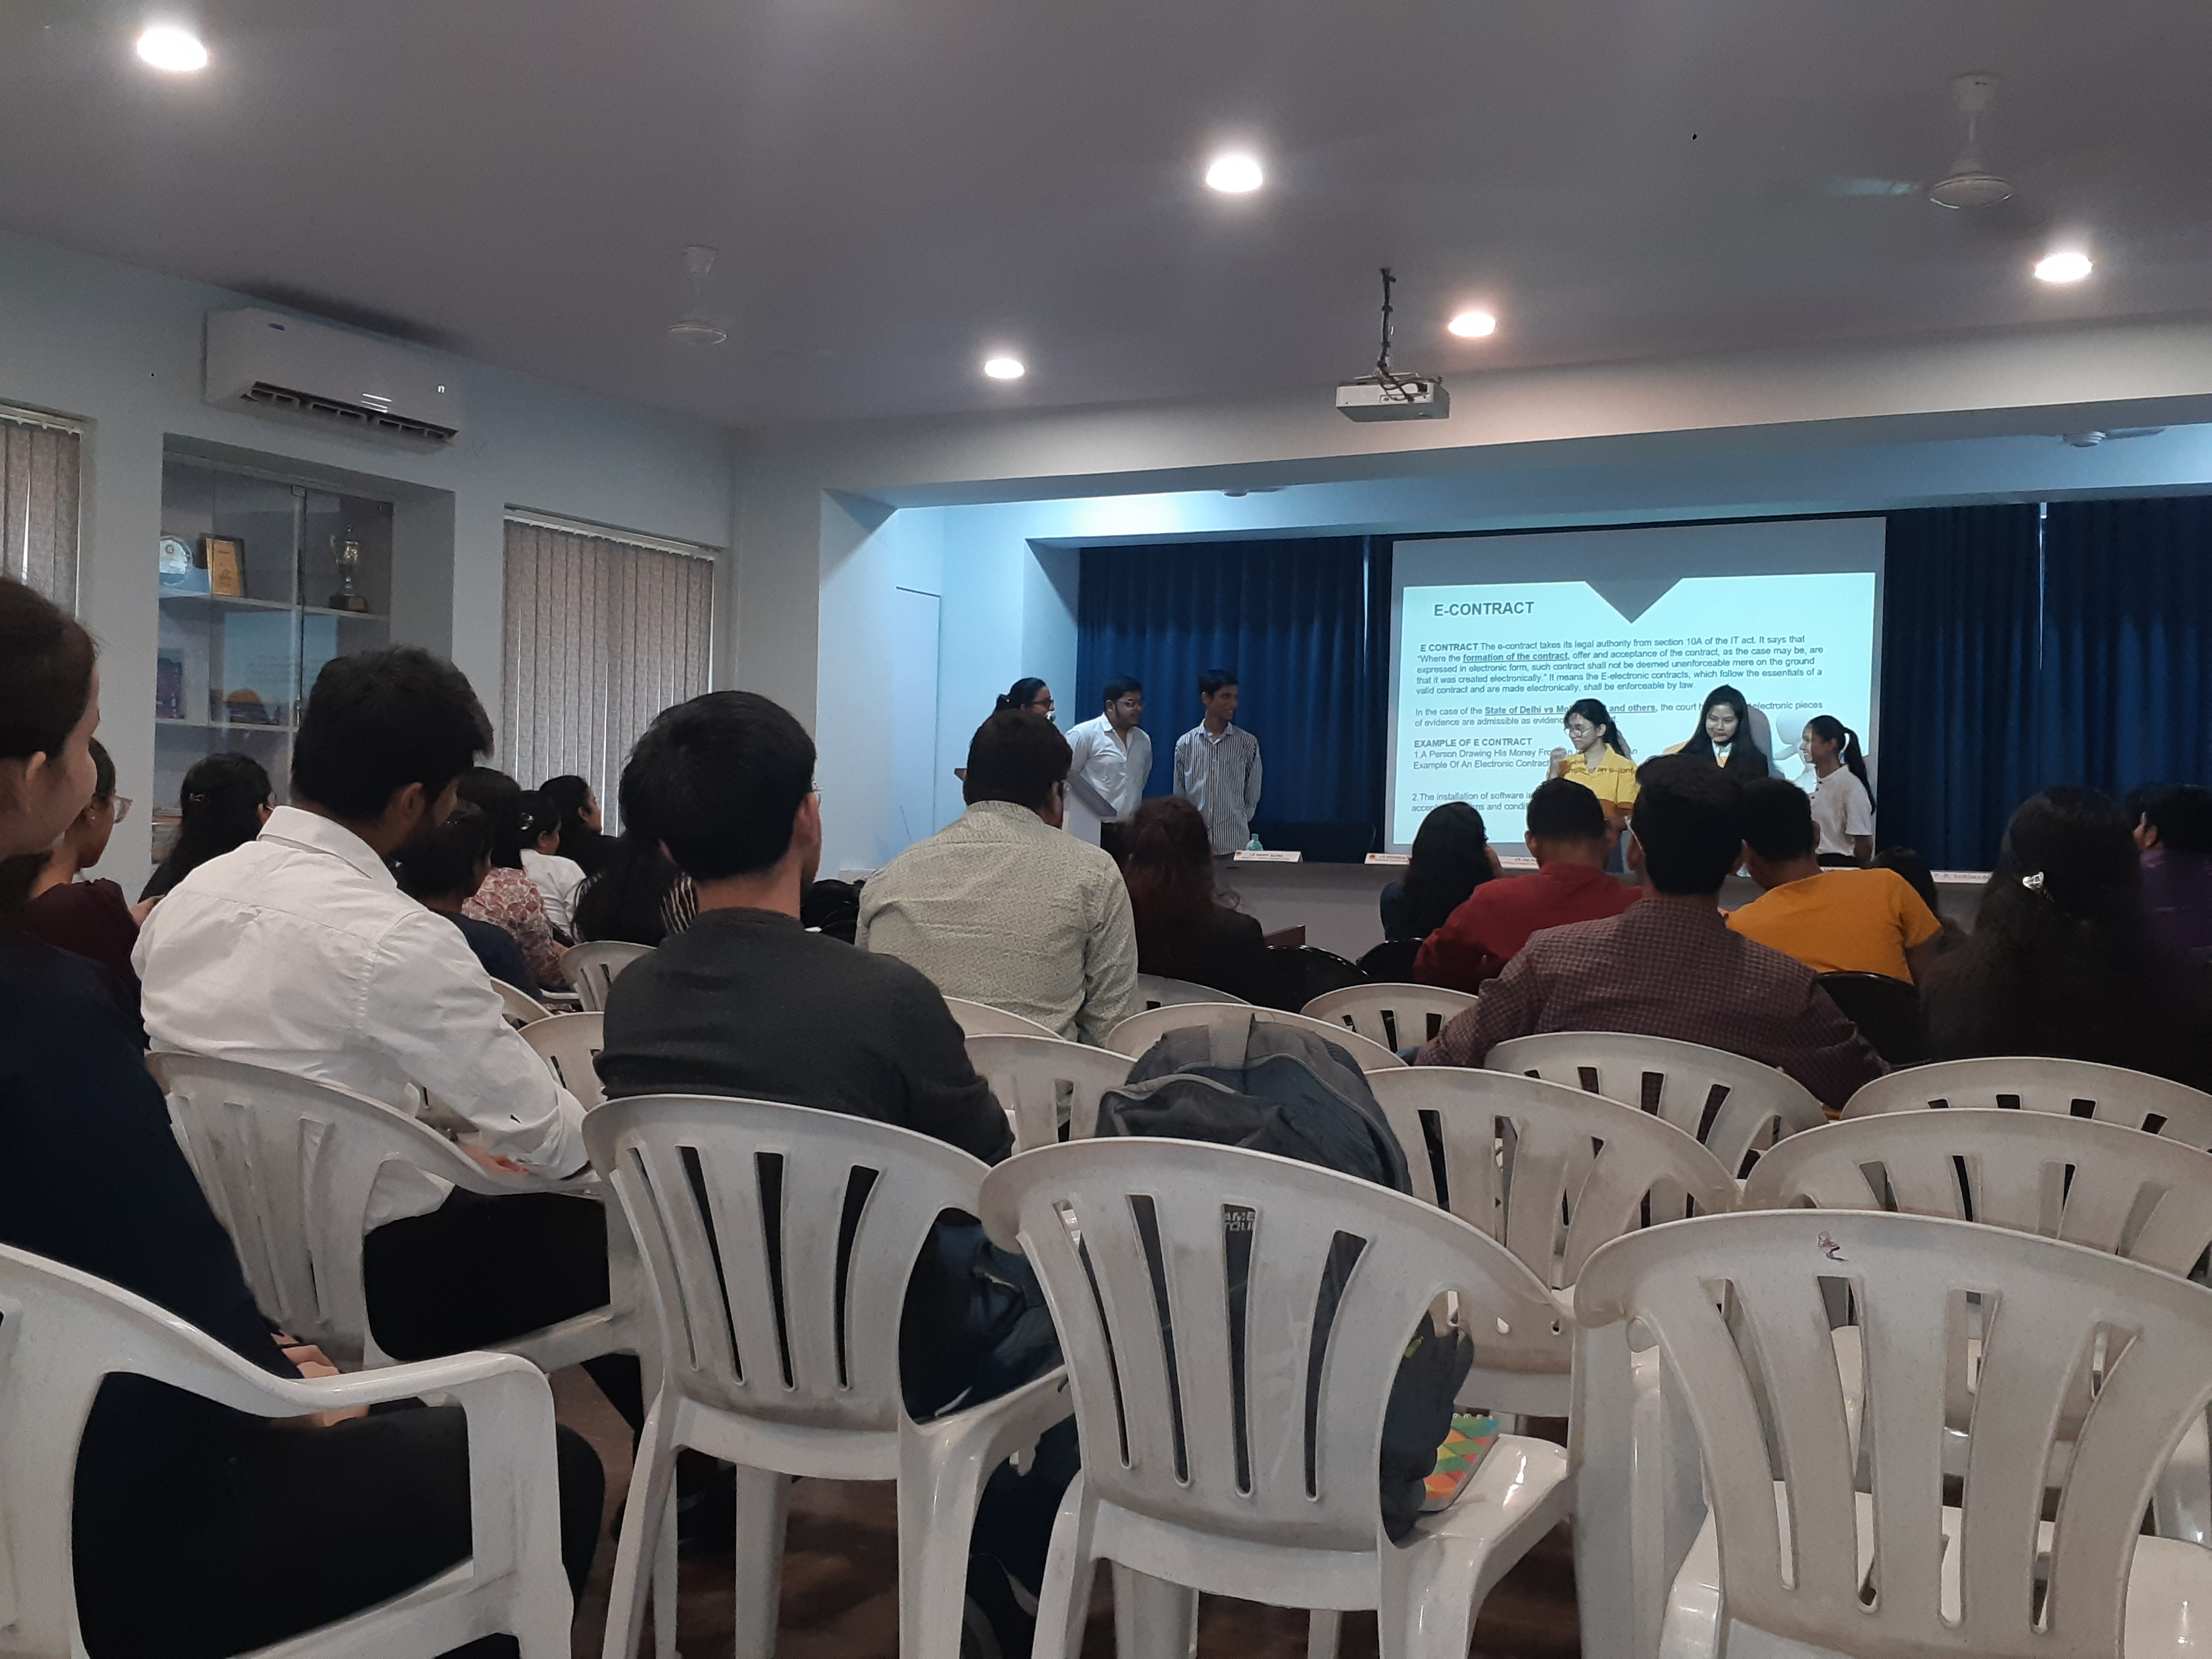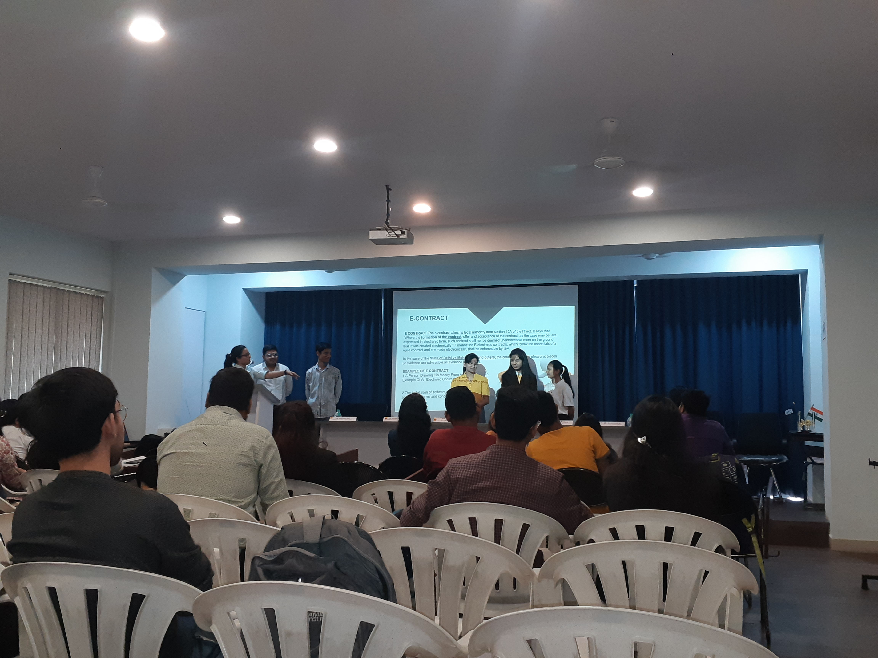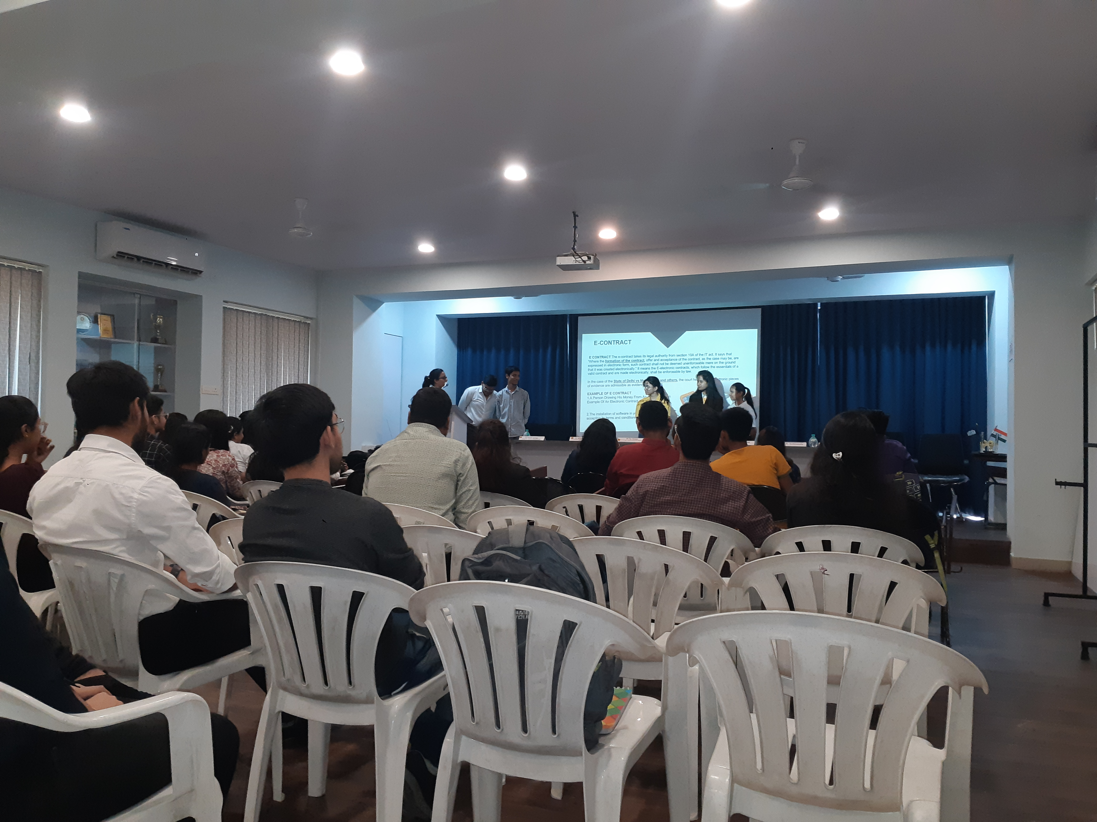

REGISTRATION OF THE STUDENTS

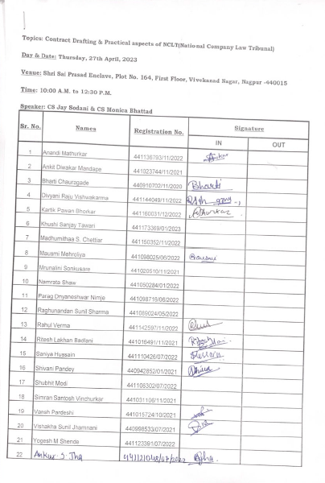

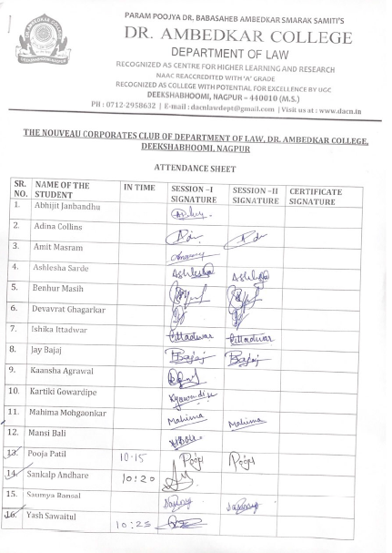

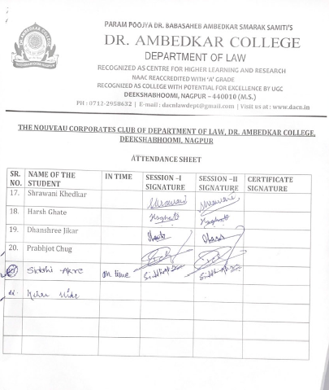
.

Certificates issued to the participants :
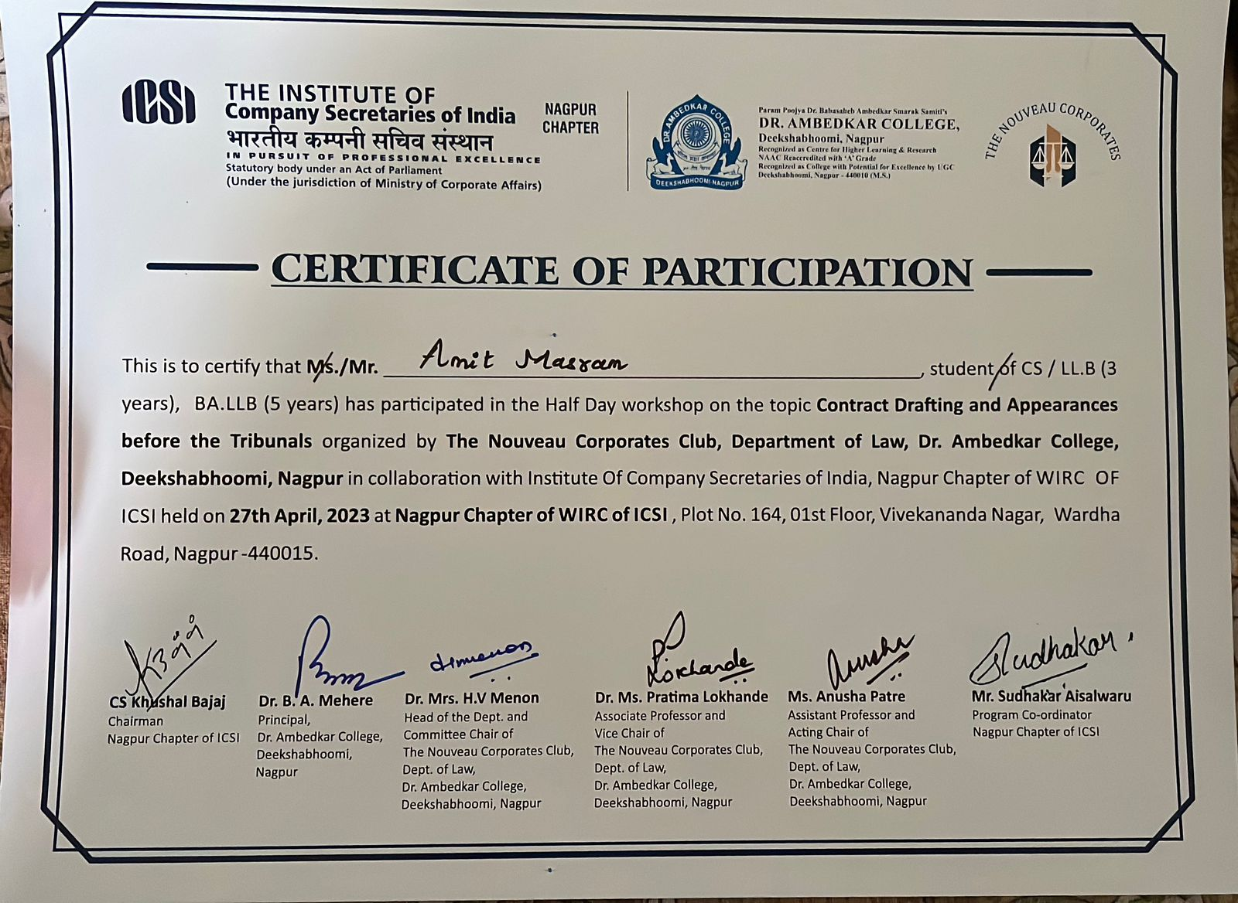
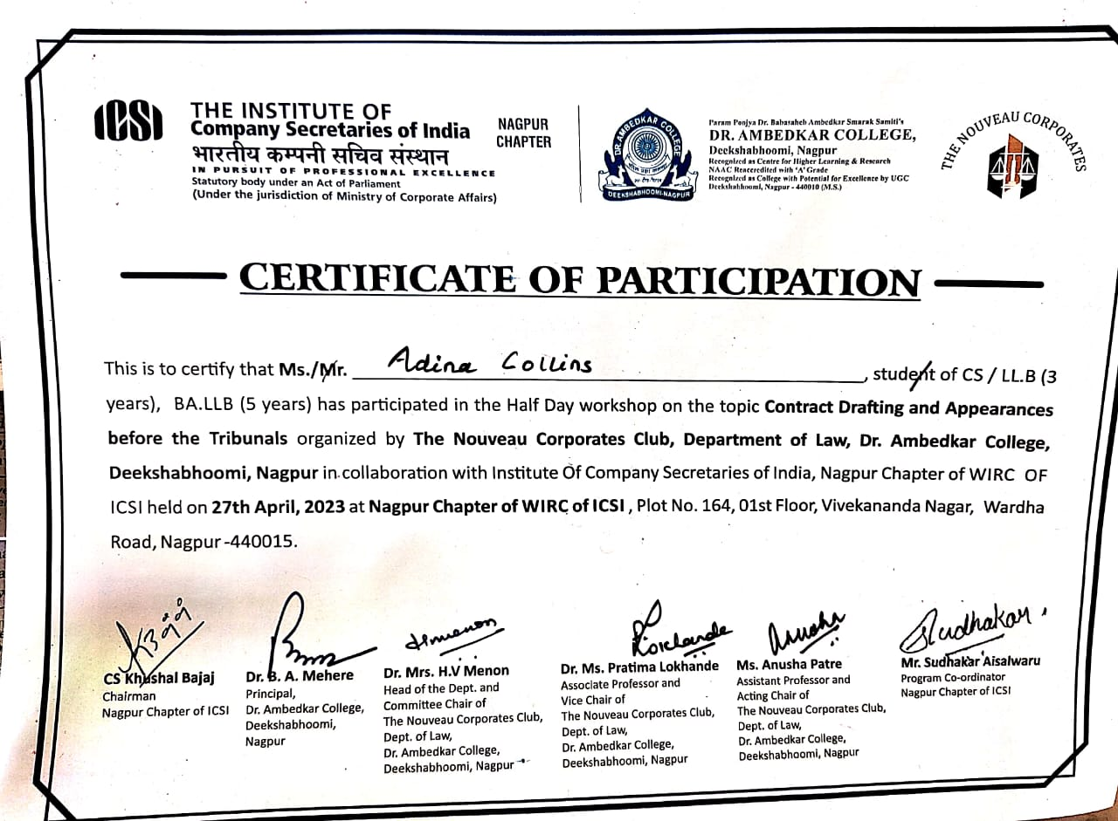
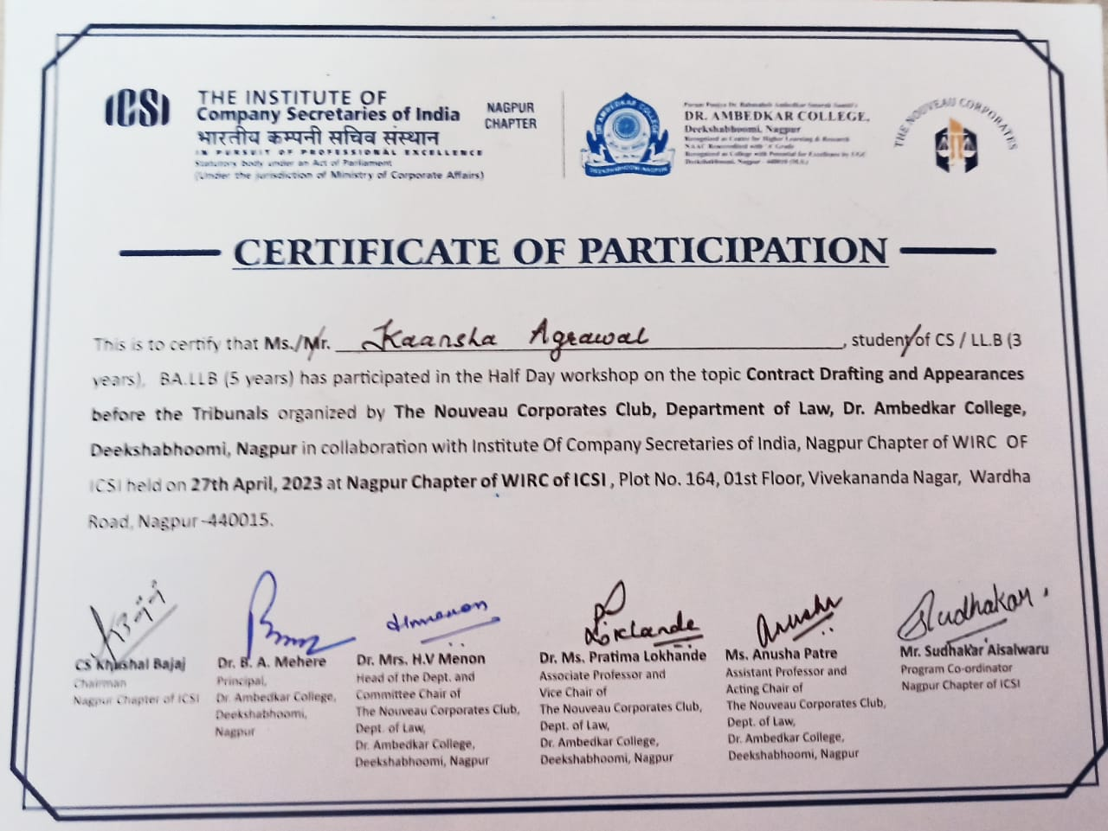
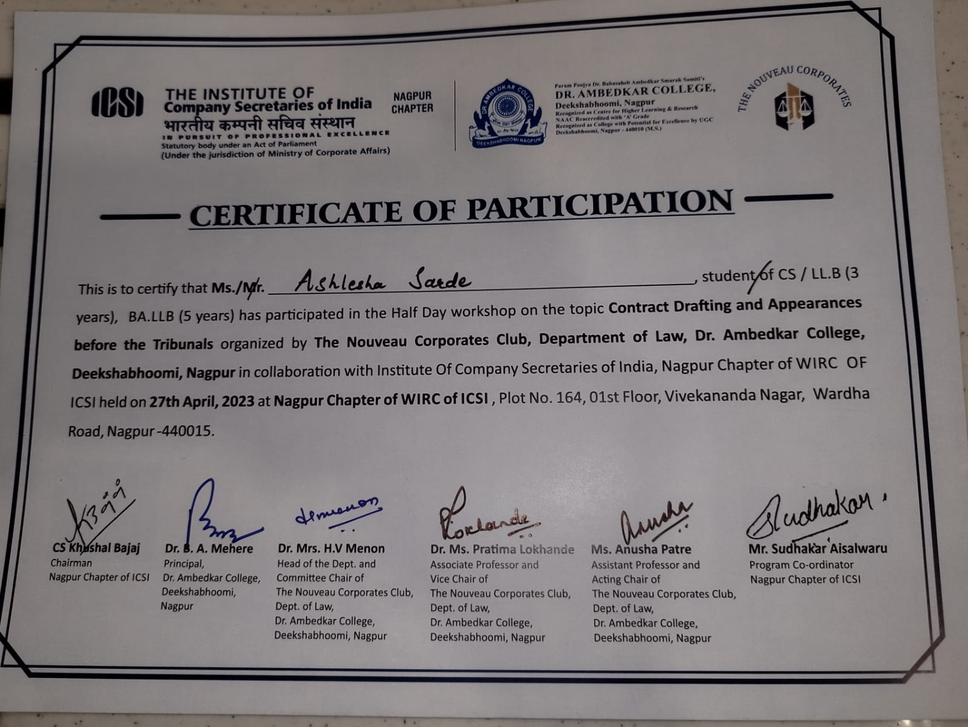

FEEDBACK FORMS
